# 1. PARTITIONING

## 1.1 TASK 1: USE INHERITANCE

### Create table

**DROP** **TABLE** **IF** **EXISTS** sales_info **CASCADE**;

**CREATE** **TABLE** sales_info (

id **INTEGER**,

category **VARCHAR**(1),

ischeck **BOOLEAN**,

eventdate **DATE**);

### 1. Create 4-5 child tables with partitioning by eventdate column. One partition is one year.

I decided to make child tables from 1st January of 2020 to 1st Janurary of 2025, since that is the last time I could take full years.

-- 2020 Partition

**DROP** **TABLE** **IF** **EXISTS** sales_info_2020 **CASCADE**;

**CREATE** **TABLE** sales_info_2020 (

**CHECK** (eventdate >= **DATE** '2020-01-01' **AND** eventdate < **DATE** '2021-01-01')

) **INHERITS** (sales_info);

-- 2021 Partition

**DROP** **TABLE** **IF** **EXISTS** sales_info_2021 **CASCADE**;

**CREATE** **TABLE** sales_info_2021 (

**CHECK** (eventdate >= **DATE** '2021-01-01' **AND** eventdate < **DATE** '2022-01-01')

) **INHERITS** (sales_info);

-- 2022 Partition

**DROP** **TABLE** **IF** **EXISTS** sales_info_2022 **CASCADE**;

**CREATE** **TABLE** sales_info_2022 (

**CHECK** (eventdate >= **DATE** '2022-01-01' **AND** eventdate < **DATE** '2023-01-01')

) **INHERITS** (sales_info);

-- 2023 Partition

**DROP** **TABLE** **IF** **EXISTS** sales_info_2023 **CASCADE**;

**CREATE** **TABLE** sales_info_2023 (

**CHECK** (eventdate >= **DATE** '2023-01-01' **AND** eventdate < **DATE** '2024-01-01')

) **INHERITS** (sales_info);

-- 2024 Partition

**DROP** **TABLE** **IF** **EXISTS** sales_info_2024 **CASCADE**;

**CREATE** **TABLE** sales_info_2024 (

**CHECK** (eventdate >= **DATE** '2024-01-01' **AND** eventdate < **DATE** '2025-01-01')

) **INHERITS** (sales_info);

### 2. Create partition function for your tables. Use following as a template:

**CREATE** **OR** **REPLACE** **FUNCTION** partition_sales_info()

**RETURNS** **trigger** **AS** **$$**

**BEGIN**

**IF** (**NEW**.eventdate >= **DATE** '2020-01-01' **AND** **NEW**.eventdate < **DATE** '2021-01-01') **THEN**

**INSERT** **INTO** sales_info_2020 **VALUES** (**NEW**.*);

**ELSIF** (**NEW**.eventdate >= **DATE** '2021-01-01' **AND** **NEW**.eventdate < **DATE** '2022-01-01') **THEN**

**INSERT** **INTO** sales_info_2021 **VALUES** (**NEW**.*);

**ELSIF** (**NEW**.eventdate >= **DATE** '2022-01-01' **AND** **NEW**.eventdate < **DATE** '2023-01-01') **THEN**

**INSERT** **INTO** sales_info_2022 **VALUES** (**NEW**.*);

**ELSIF** (**NEW**.eventdate >= **DATE** '2023-01-01' **AND** **NEW**.eventdate < **DATE** '2024-01-01') **THEN**

**INSERT** **INTO** sales_info_2023 **VALUES** (**NEW**.*);

**ELSIF** (**NEW**.eventdate >= **DATE** '2024-01-01' **AND** **NEW**.eventdate < **DATE** '2025-01-01') **THEN**

**INSERT** **INTO** sales_info_2024 **VALUES** (**NEW**.*);

**ELSE**

**RAISE** **EXCEPTION** 'Out of range date: %', **NEW**.eventdate;

**END** **IF**;

**RETURN** **NULL**;

**END**;

**$$** **LANGUAGE** plpgsql;

### 3. Create trigger for your function and tables. Use following as a template:

**CREATE** **TRIGGER** partition_sales_info_trigger

**BEFORE** **INSERT** **ON** sales_info

**FOR** **EACH** **ROW** **EXECUTE** **FUNCTION** partition_sales_info();

### 4. Generate test data and insert in SALES_INFO table:

The formula that was provided in the task takes random date, so it is falling out of the range of any partition, so it raises error

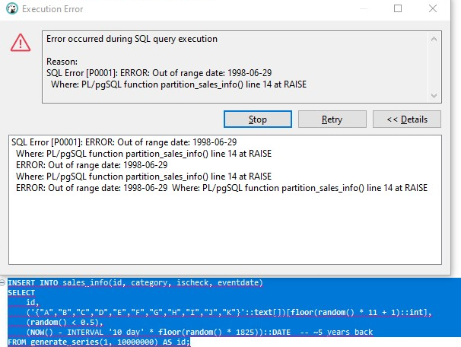

I adjusted the formula to take only dates within our partitions.

**INSERT** **INTO** sales_info(id, category, ischeck, eventdate)

**SELECT**

id,

('{"A","B","C","D","E","F","G","H","I","J","K"}'::**text**[])[**floor**(**random**() * 11 + 1)::**int**],

(**random**() < 0.5),

(**DATE** '2020-01-01' + (**floor**(**random**() * 1826) * INTERVAL '1 day'))::**DATE** -- ~5 years

**FROM** **generate_series**(1, 10000000) **AS** id;

This query took almost 6 minutes to load.

### 5. Update some rows in SALES_INFO and set another eventdate.

Fot this step I moved 1% of 2021 data to 2023

**WITH** to_move **AS** (

**SELECT** * **FROM** sales_info_2021

**WHERE** **random**() < 0.01

)

**DELETE** **FROM** sales_info_2021

**WHERE** id **IN** (**SELECT** id **FROM** to_move);

**WITH** to_move **AS** (

**SELECT** * **FROM** sales_info_2021

**WHERE** **random**() < 0.01

)

**INSERT** **INTO** sales_info (id, category, ischeck, eventdate)

**SELECT** id, category, ischeck, eventdate + INTERVAL '2 years'

**FROM** to_move;

### 6. Create table SALES_INFO_SIMPLE with the same structure as SALES_INFO but without partitioning. Insert test data from the 5th step. Compare plans of different queries:

**DROP** **TABLE** **IF** **EXISTS** sales_info_simple;

**CREATE** **TABLE** sales_info_simple (

id **INTEGER**,

category **VARCHAR**(1),

ischeck **BOOLEAN**,

eventdate **DATE**

);

**INSERT** **INTO** sales_info_simple

**SELECT** *

**FROM** sales_info

**WHERE** eventdate **BETWEEN** **DATE** '2023-01-01' **AND** **DATE** '2023-12-31';

#### Select all

**EXPLAIN** **ANALYZE** **SELECT** * **FROM** sales_info;

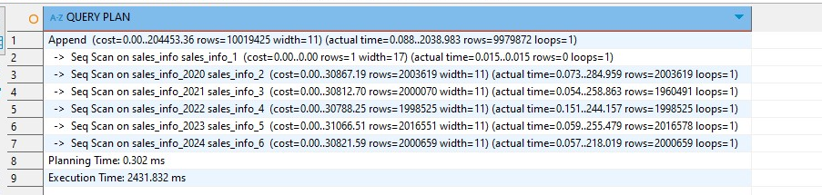

**EXPLAIN** **ANALYZE** **SELECT** * **FROM** sales_info_simple;

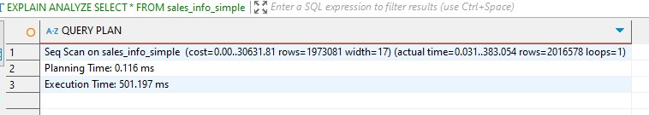

The SELECT * query on the partitioned sales_info table was significantly slower (2431 ms) than on the flat sales_info_simple table (501 ms) because PostgreSQL had to scan all partitions individually using an Append strategy, demonstrating that partitioning introduces overhead for full table scans without filters, so **partitioning is not beneficial for** SELECT* **queries** over all data.

#### 2. Select with range of dates

**EXPLAIN** **ANALYZE**

**SELECT** * **FROM** sales_info

**WHERE** eventdate **BETWEEN** '2023-06-01' **AND** '2023-06-30';

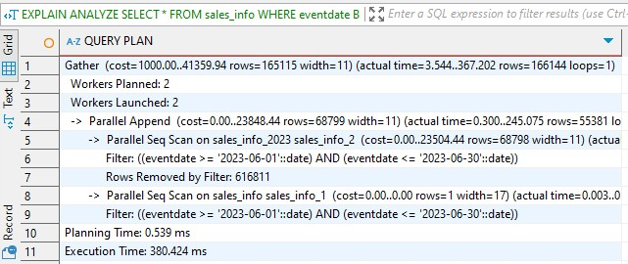

**EXPLAIN** **ANALYZE**

**SELECT** * **FROM** sales_info_simple

**WHERE** eventdate **BETWEEN** '2023-06-01' **AND** '2023-06-30';

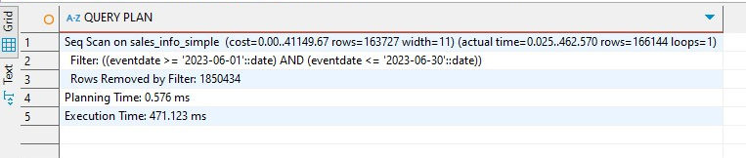

In this case, the SELECT query with a date range filter was faster on the partitioned sales_info table (380 ms) than on the flat sales_info_simple table (471 ms), because PostgreSQL scanned only the matching one (sales_info_2023), showing the performance advantage of partitioning for filtered queries.

#### 3. Select exact date

**EXPLAIN** **ANALYZE**

**SELECT** * **FROM** sales_info

**WHERE** eventdate = '2024-08-17';

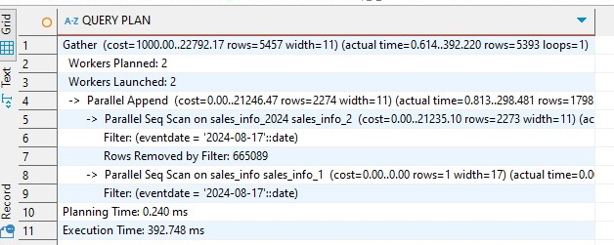

**EXPLAIN** **ANALYZE**

**SELECT** * **FROM** sales_info_simple

**WHERE** eventdate = '2025-08-17';

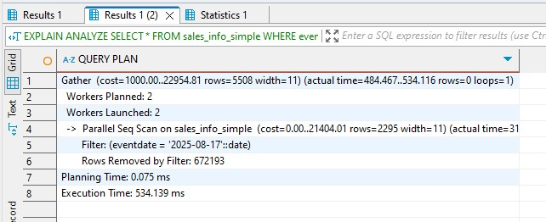

The SELECT query for an exact date performed faster on the partitioned sales_info table (393 ms) compared to the flat sales_info_simple table (534 ms), because PostgreSQL scanned only the relevant partition (sales_info_2024) using partition pruning. In contrast, the flat table required scanning all rows and filtering them.

#### 4. Count of all rows

**EXPLAIN** **ANALYZE** **SELECT** **COUNT**(*) **FROM** sales_info;

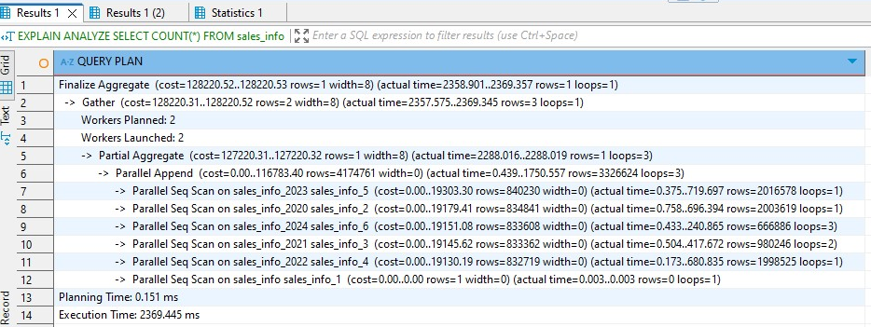

**EXPLAIN** **ANALYZE** **SELECT** **COUNT**(*) **FROM** sales_info_simple;

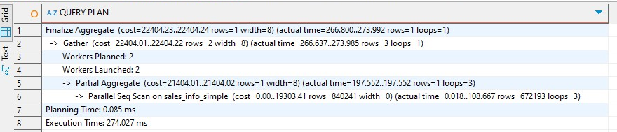

The COUNT(*) query was significantly faster on the flat sales_info_simple table (274 ms) than on the partitioned sales_info table (2369 ms), because PostgreSQL had to scan and aggregate across all partitions individually in the partitioned setup, while the flat table allowed a single parallel scan and aggregate over one structure.

#### 5. Count of rows with range of dates

**EXPLAIN** **ANALYZE**

**SELECT** **COUNT**(*) **FROM** sales_info

**WHERE** eventdate >= '2022-01-01' **AND** eventdate < '2022-01-06';

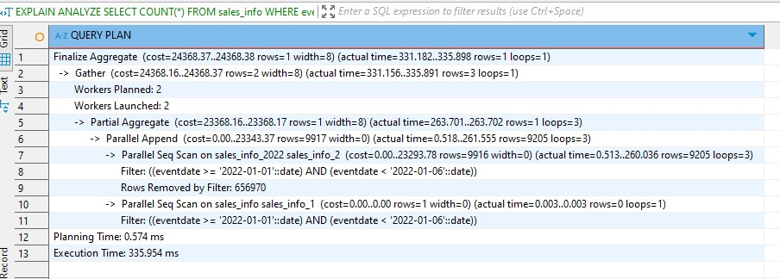

**EXPLAIN** **ANALYZE**

**SELECT** **COUNT**(*) **FROM** sales_info_simple

**WHERE** eventdate >= '2022-01-01' **AND** eventdate < '2022-01-06';

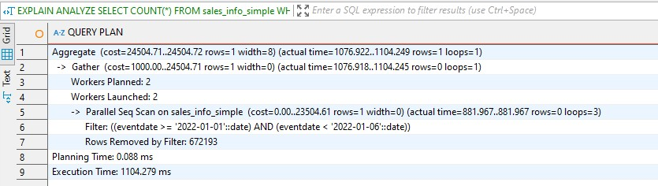

The COUNT(*) query with a date range was significantly faster on the partitioned sales_info table (336 ms) than on the flat sales_info_simple table (1104 ms), because PostgreSQL scanned only the matching partition (sales_info_2022), reducing the amount of data read and aggregated.

To conclude all of this a flat, unpartitioned table like sales_info_simple is easy to maintain but performs poorly on date-filtered queries. In contrast, the partitioned sales_info table benefits from partition pruning, where only relevant child tables are scanned.

### 7. Delete one of partition (the oldest one). Create some general table like sales_info_3000 with the same structure as sales_info and add it as new partition.

-- deleting the oldest partitiom

**DROP** **TABLE** **IF** **EXISTS** sales_info_2020 **CASCADE**;

-- creating a future plan

**DROP** **TABLE** **IF** **EXISTS** sales_info_3000 **CASCADE**;

**CREATE** **TABLE** sales_info_3000 (

**CHECK** (eventdate >= **DATE** '3000-01-01' **AND** eventdate < **DATE** '4000-01-01')

) **INHERITS** (sales_info);

-- updating trigger

**CREATE** **OR** **REPLACE** **FUNCTION** partition_sales_info()

**RETURNS** **trigger** **AS** **$$**

**BEGIN**

**IF** (**NEW**.eventdate >= **DATE** '2021-01-01' **AND** **NEW**.eventdate < **DATE** '2022-01-01') **THEN**

**INSERT** **INTO** sales_info_2021 **VALUES** (**NEW**.*);

**ELSIF** (**NEW**.eventdate >= **DATE** '2022-01-01' **AND** **NEW**.eventdate < **DATE** '2023-01-01') **THEN**

**INSERT** **INTO** sales_info_2022 **VALUES** (**NEW**.*);

**ELSIF** (**NEW**.eventdate >= **DATE** '2023-01-01' **AND** **NEW**.eventdate < **DATE** '2024-01-01') **THEN**

**INSERT** **INTO** sales_info_2023 **VALUES** (**NEW**.*);

**ELSIF** (**NEW**.eventdate >= **DATE** '2024-01-01' **AND** **NEW**.eventdate < **DATE** '2025-01-01') **THEN**

**INSERT** **INTO** sales_info_2024 **VALUES** (**NEW**.*);

**ELSIF** (**NEW**.eventdate >= **DATE** '3000-01-01' **AND** **NEW**.eventdate < **DATE** '4000-01-01') **THEN**

**INSERT** **INTO** sales_info_3000 **VALUES** (**NEW**.*);

**ELSE**

**RAISE** **EXCEPTION** 'Out of range date: %', **NEW**.eventdate;

**END** **IF**;

**RETURN** **NULL**;

**END**;

**$$** **LANGUAGE** plpgsql;

## 1.2 TASK2: USE DECLARATIVE PARTITIONING

### 1. Create table SALES_INFO_DP with structure:

**DROP** **TABLE** **IF** **EXISTS** sales_info_dp **CASCADE**;

**CREATE** **TABLE** sales_info_dp (

id **INTEGER**,

category **VARCHAR**(1),

ischeck **BOOLEAN**,

eventdate **DATE**

)

**PARTITION** **BY** **RANGE** (eventdate);

### 2. Create 4-5 child tables with partitioning by eventdate column. One partition is one year. Each child table should be partitioned by list on category column. Use 2 lists of values and one default partition here. As a result you should have SALES_INFO_DP table with composite partitioning by range and list.

For this part, I made partition for 2020 and subpartitions for categories and than I automitized it to do the same for years after it, to avoid repetition.

-- 2020 partition

**CREATE** **TABLE** sales_info_dp_2020 **PARTITION** **OF** sales_info_dp

**FOR** **VALUES** **FROM** ('2020-01-01') **TO** ('2021-01-01')

**PARTITION** **BY** LIST (category);

-- subpartitions by category

**CREATE** **TABLE** sales_info_dp_2020_abcd **PARTITION** **OF** sales_info_dp_2020

**FOR** **VALUES** **IN** ('A', 'B', 'C', 'D');

**CREATE** **TABLE** sales_info_dp_2020_efgh **PARTITION** **OF** sales_info_dp_2020

**FOR** **VALUES** **IN** ('E', 'F', 'G', 'H');

**CREATE** **TABLE** sales_info_dp_2020_default **PARTITION** **OF** sales_info_dp_2020

**DEFAULT**;

-- repeating for 2021–2024

**DO** **$$**

**DECLARE**

y **int**;

**BEGIN**

**FOR** y **IN** 2021..2024 **LOOP**

**EXECUTE** **format**(**$f$**

**CREATE** **TABLE** sales_info_dp_%1$s **PARTITION** **OF** sales_info_dp

**FOR** **VALUES** **FROM** ('%1$s-01-01') **TO** ('%1$s-12-31'::**date** + **INTERVAL** '1 day')

**PARTITION** **BY** LIST (category);

**$f$**, y);

**EXECUTE** **format**(**$f$**

**CREATE** **TABLE** sales_info_dp_%1$s_abcd **PARTITION** **OF** sales_info_dp_%1$s

**FOR** **VALUES** **IN** ('A', 'B', 'C', 'D');

**$f$**, y);

**EXECUTE** **format**(**$f$**

**CREATE** **TABLE** sales_info_dp_%1$s_efgh **PARTITION** **OF** sales_info_dp_%1$s

**FOR** **VALUES** **IN** ('E', 'F', 'G', 'H');

**$f$**, y);

**EXECUTE** **format**(**$f$**

**CREATE** **TABLE** sales_info_dp_%1$s_default **PARTITION** **OF** sales_info_dp_%1$s

**DEFAULT**;

**$f$**, y);

**END** **LOOP**;

**END$$**;

### 3. Add date to partitioned table:

**INSERT** **INTO** sales_info_dp (id, category, ischeck, eventdate)

**SELECT** id,

('{"A","B","C","D","E","F","G","H","I","J","K"}'::**text**[])[**floor**(**random**() * 11 + 1)::**int**],

(**random**() < 0.5),

(**DATE** '2020-01-01' + **floor**(**random**() * 1826) * INTERVAL '1 day')::**date**

**FROM** **generate_series**(1, 10000000) **AS** id;

### 4. Update some rows in SALES_INFO_DP and set another category.

**UPDATE** sales_info_dp

**SET** category = 'F'

**WHERE** category = 'A'

**AND** eventdate **BETWEEN** **DATE** '2021-01-01' **AND** **DATE** '2021-12-31';

### 5. Compare plans of different queries for tables SALES_INFO_DP and SALES_INFO_SIMPLE:

#### Select all

**EXPLAIN** **ANALYZE** **SELECT** * **FROM** sales_info_dp;

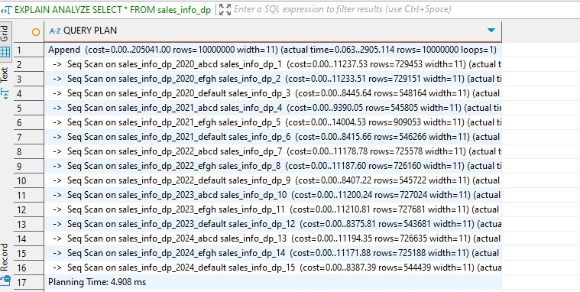

**EXPLAIN** **ANALYZE** **SELECT** * **FROM** sales_info_simple;

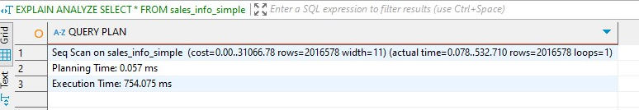

The SELECT * query on the declaratively partitioned sales_info_dp table was significantly slower (2905 ms) than on the flat sales_info_simple table (754 ms), because PostgreSQL had to scan all subpartitions individually and merge their results using an Append node, demonstrating that full table scans are less efficient in partitioned tables without filtering conditions.

#### Select with range of dates

**EXPLAIN** **ANALYZE**

**SELECT** * **FROM** sales_info_dp

**WHERE** eventdate **BETWEEN** '2023-06-01' **AND** '2023-06-30';

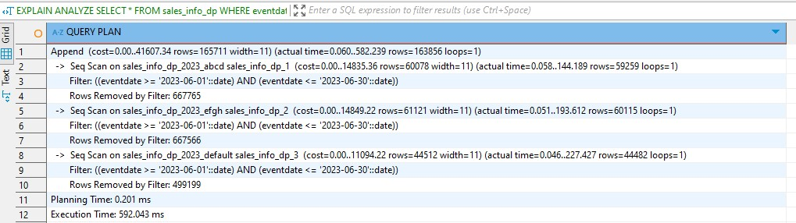

**EXPLAIN** **ANALYZE**

**SELECT** * **FROM** sales_info_simple

**WHERE** eventdate **BETWEEN** '2023-06-01' **AND** '2023-06-30';

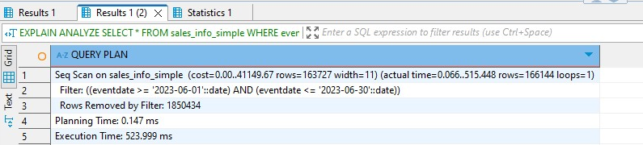

The SELECT query with a date range performed slightly better on the flat sales_info_simple table (524 ms) than on the declaratively partitioned sales_info_dp table (592 ms), because although partition pruning reduced the number of scanned partitions, multiple scans and result appending introduced overhead compared to the single sequential scan in the flat table.

#### Select the exact date

**EXPLAIN** **ANALYZE**

**SELECT** * **FROM** sales_info_dp

**WHERE** eventdate = '2024-08-17';

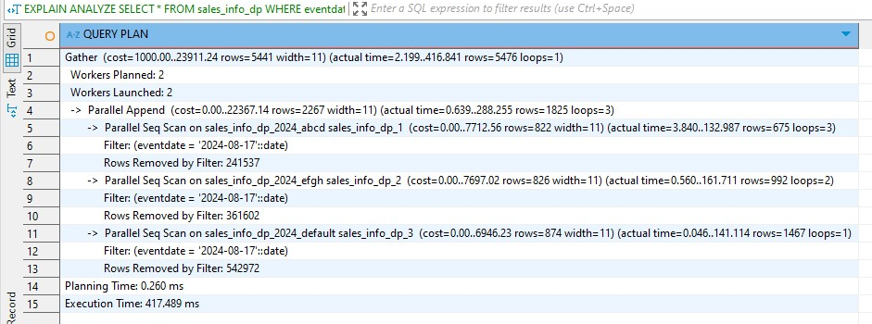

**EXPLAIN** **ANALYZE**

**SELECT** * **FROM** sales_info_simple

**WHERE** eventdate = '2024-08-17';

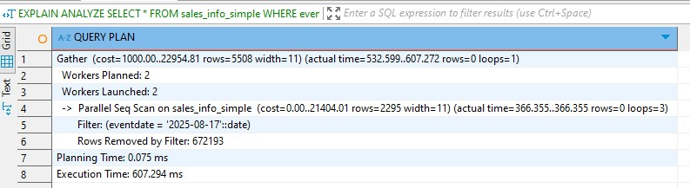

The SELECT query for an exact executed faster on the declaratively partitioned sales_info_dp table (353 ms) compared to the flat sales_info_simple table (607 ms), because PostgreSQL was able to prune unrelated partitions and scan only the relevant subpartition, while the flat table had to scan all rows and apply the filter. ( I noticed later that one date was different from other and even out of range of partition but the conclusion is still the same)

#### Select exact category

**EXPLAIN** **ANALYZE**

**SELECT** *

**FROM** sales_info_dp

**WHERE** category = 'A';

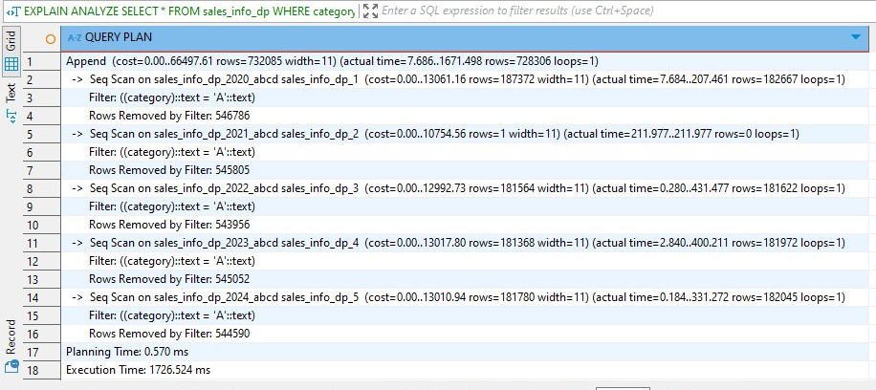

**EXPLAIN** **ANALYZE**

**SELECT** *

**FROM** sales_info_simple

**WHERE** category = 'A';

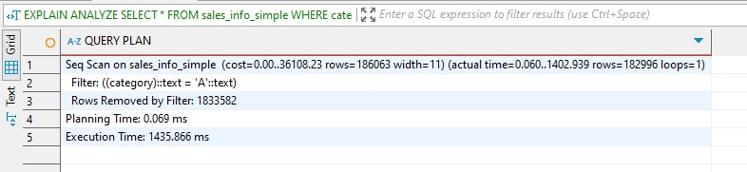

The SELECT query for category 'A' executed slower on the declaratively partitioned sales_info_dp table (1726 ms) than on the flat sales_info_simple table (1436 ms), because although partition pruning by category helped reduce the number of scanned partitions, the overhead of scanning multiple subpartitions still outweighed the single sequential scan on the flat table.

#### Select a list of categories

**EXPLAIN** **ANALYZE**

**SELECT** *

**FROM** sales_info_dp

**WHERE** category **IN** ('A', 'B', 'C');

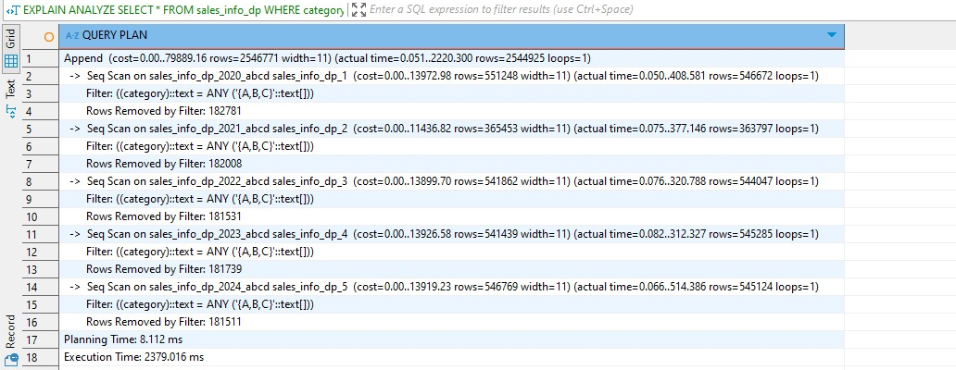

**EXPLAIN** **ANALYZE**

**SELECT** *

**FROM** sales_info_simple

**WHERE** category **IN** ('A', 'B', 'C');

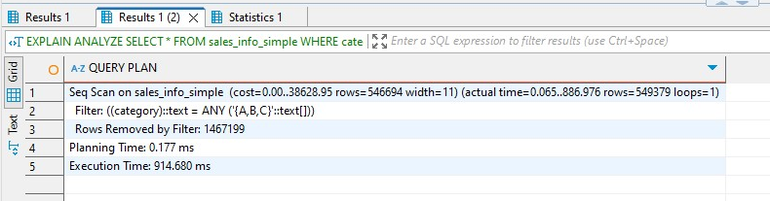

The SELECT query for categories 'A', 'B', 'C' was significantly slower on the declaratively partitioned sales_info_dp table (2379 ms) compared to the flat sales_info_simple table (915 ms), because even though list partition pruning occurred, the planner had to scan multiple subpartitions separately and combine their results, introducing more overhead than the single sequential scan in the flat structure.

#### Select a list of categories in exact date

**EXPLAIN** **ANALYZE**

**SELECT** *

**FROM** sales_info_dp

**WHERE** eventdate = **DATE** '2023-06-01'

**AND** category **IN** ('A', 'B', 'C');

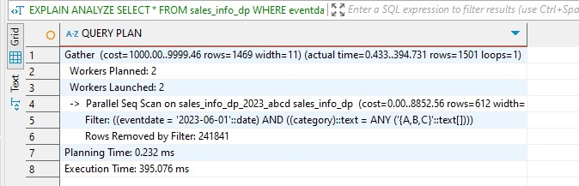

**EXPLAIN** **ANALYZE**

**SELECT** *

**FROM** sales_info_simple

**WHERE** eventdate = **DATE** '2023-06-01'

**AND** category **IN** ('A', 'B', 'C');

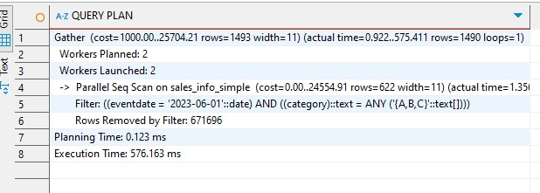

The SELECT query filtering both eventdate and category executed faster on the declaratively partitioned sales_info_dp table (395 ms) than on the flat sales_info_simple table (576 ms), because PostgreSQL successfully pruned partitions by both date and category, scanning only the relevant subpartition and reducing the number of rows processed.

#### Count of all rows

**EXPLAIN** **ANALYZE**

**SELECT** **COUNT**(*) **FROM** sales_info_dp;

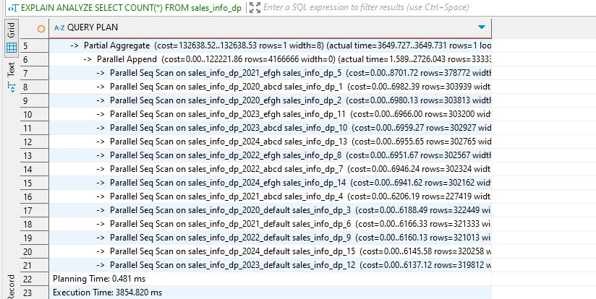

**EXPLAIN** **ANALYZE**

**SELECT** **COUNT**(*) **FROM** sales_info_simple;

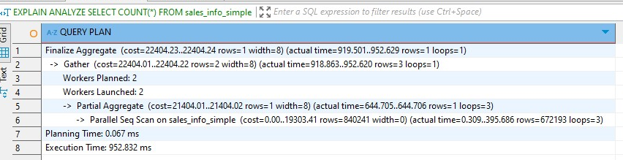

The COUNT(*) query was significantly faster on the flat sales_info_simple table (952 ms) than on the declaratively partitioned sales_info_dp table (3855 ms), because the flat table required only a single parallel scan and aggregation, while the partitioned table had to scan and aggregate results from many subpartitions individually, increasing execution time due to plan complexity and coordination overhead.

#### Count of rows with range of dates

**EXPLAIN** **ANALYZE**

**SELECT** **COUNT**(*)

**FROM** sales_info_dp

**WHERE** eventdate **BETWEEN** **DATE** '2022-01-01' **AND** **DATE** '2022-12-31';

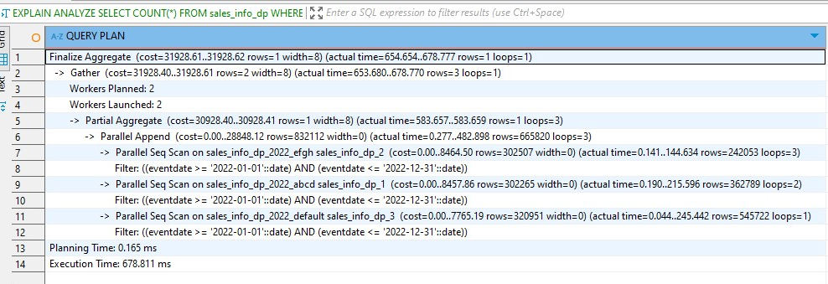

**EXPLAIN** **ANALYZE**

**SELECT** **COUNT**(*)

**FROM** sales_info_simple

**WHERE** eventdate **BETWEEN** **DATE** '2022-01-01' **AND** **DATE** '2022-12-31';

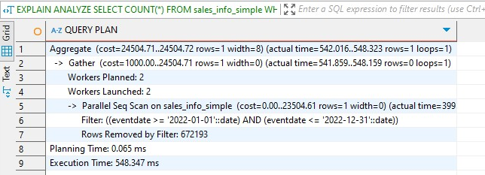

The COUNT(*) query with a date range was slightly faster on the flat sales_info_simple table (548 ms) than on the declaratively partitioned sales_info_dp table (679 ms), despite partition pruning narrowing the scan to just relevant subpartitions, as the overhead of scanning and aggregating across multiple partitions slightly outweighed the efficiency of a single parallel scan.

### 6. For one of the child tables with range partition by eventdate split one list partition for two. For example:

-- detaching dropping

**ALTER** **TABLE** sales_info_dp_2020 **DETACH** **PARTITION** sales_info_dp_2020_abcd;

**DROP** **TABLE** sales_info_dp_2020_abcd;

-- create partition for A, B, C

**CREATE** **TABLE** sales_info_dp_2020_abc **PARTITION** **OF** sales_info_dp_2020

**FOR** **VALUES** **IN** ('A', 'B', 'C');

-- create partition for D

**CREATE** **TABLE** sales_info_dp_2020_d **PARTITION** **OF** sales_info_dp_2020

**FOR** **VALUES** **IN** ('D');

-- droping the two new subpartitions

**DROP** **TABLE** sales_info_dp_2020_abc;

**DROP** **TABLE** sales_info_dp_2020_d;

-- aand recreating the original unified partition

**CREATE** **TABLE** sales_info_dp_2020_abcd **PARTITION** **OF** sales_info_dp_2020

**FOR** **VALUES** **IN** ('A', 'B', 'C', 'D');

Splitting a list partition into two separate partitions and then reverting it in PostgreSQL requires manually detaching and dropping the original partition, creating new ones for the desired value subsets, and optionally recreating the original partition; this process demonstrates the flexibility of declarative partitioning but also highlights the need for careful planning and manual intervention when modifying partition boundaries.

# 2. PARALLEL EXECUTION

## 2.1 TASK 3: USE PARALLEL QUERING

### 1. Add parallel workers: set max_parallel_workers_per_gather=4;]

**SET** max_parallel_workers_per_gather = 4;

### 2. Analyze plans for tables SALES_INFO, SALES_INFO_DP and SALES_INFO_SIMPLE by querying:

#### Select all from tables

**EXPLAIN** **ANALYZE** **SELECT** * **FROM** sales_info **WHERE** ischeck **IS** **TRUE**;

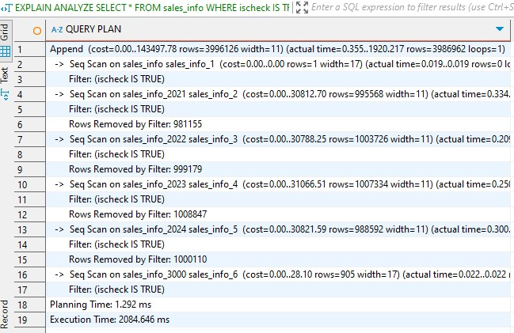

**EXPLAIN** **ANALYZE** **SELECT** * **FROM** sales_info_simple **WHERE** ischeck **IS** **TRUE**;

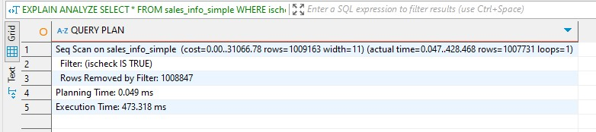

**EXPLAIN** **ANALYZE** **SELECT** * **FROM** sales_info_dp **WHERE** ischeck **IS** **TRUE**;

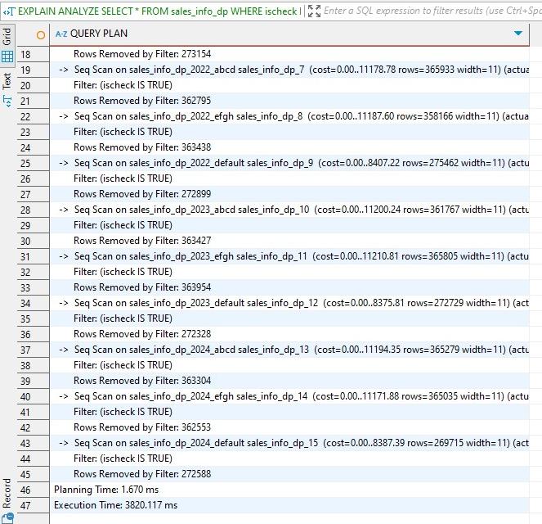

The sales_info_simple table performs best due to its flat structure and efficient sequential scanning. The sales_info table is slower because it must scan multiple range partitions, and sales_info_dp is the slowest due to additional overhead from scanning both range and list partitions, especially since ischeck is not a partitioning key.

#### Add order by eventadate

**EXPLAIN** **ANALYZE** **SELECT** * **FROM** sales_info **ORDER** **BY** eventdate **DESC**;

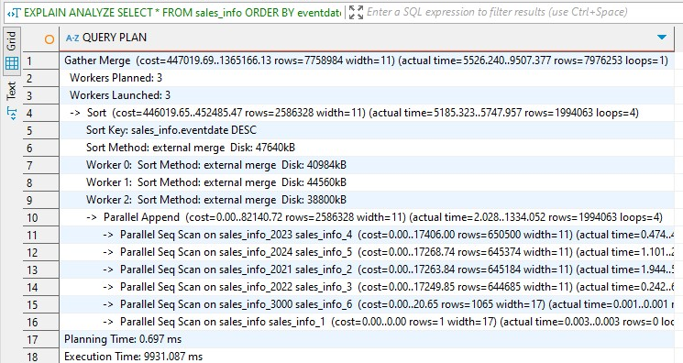

**EXPLAIN** **ANALYZE** **SELECT** * **FROM** sales_info_simple **ORDER** **BY** eventdate **DESC**;

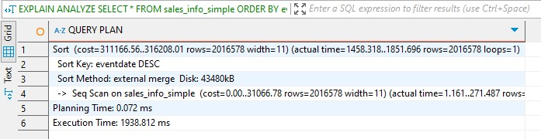

**EXPLAIN** **ANALYZE** **SELECT** * **FROM** sales_info_dp **ORDER** **BY** eventdate **DESC**;

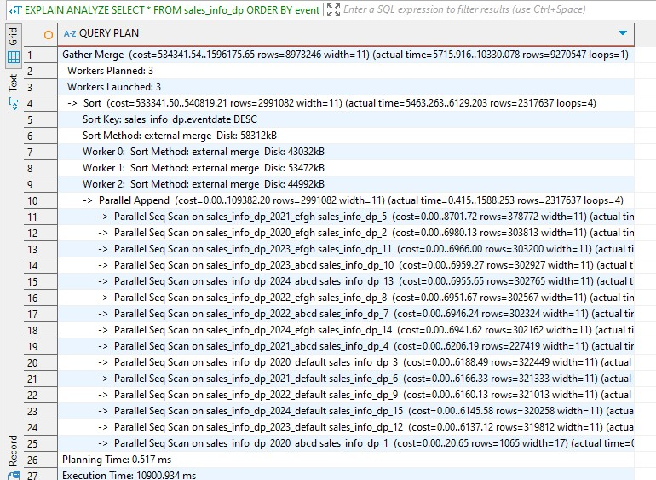

While partitioning helps with filtering, it adds overhead to global operations like ORDER BY, especially without indexes. Flat tables with fewer relations and more predictable row access patterns benefit more during full-table sorts, so once again flat table outperforms other two.

#### Select count of all rows

**EXPLAIN** **ANALYZE** **SELECT** **COUNT**(*) **FROM** sales_info;

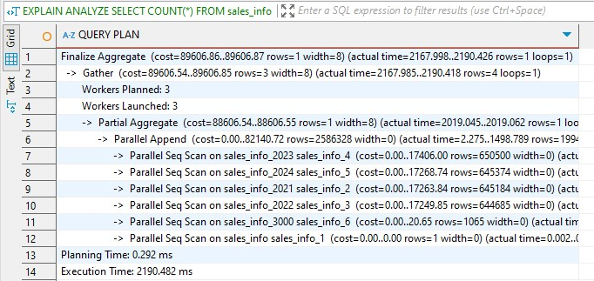

**EXPLAIN** **ANALYZE** **SELECT** **COUNT**(*) **FROM** sales_info_simple;

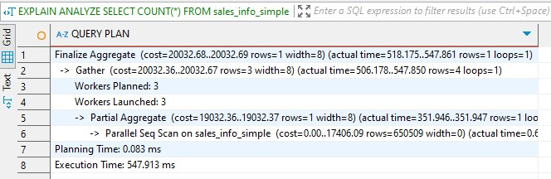

**EXPLAIN** **ANALYZE** **SELECT** **COUNT**(*) **FROM** sales_info_dp;

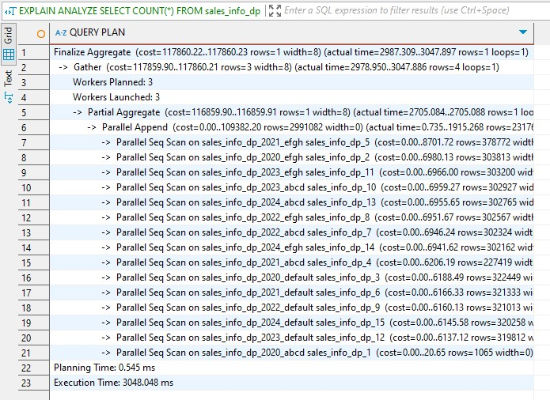

The sales_info_simple table delivered the best performance for counting rows with an execution time of approximately 548 ms, thanks to its flat structure and efficient use of parallel sequential scans. In contrast, the sales_info table, which uses inherited child tables, was slower at around 2190 ms due to the additional overhead of scanning multiple tables without effective pruning. The sales_info_dp table, despite being partitioned and using parallel scans, had the slowest performance at about 3048 ms because the overhead of scanning and appending across many partitions outweighed the benefits of partitioning. This demonstrates that for queries like COUNT(*) where partition pruning does not apply, a flat table structure with parallel querying offers superior performance.

#### Add range of dates

**EXPLAIN** **ANALYZE**

**SELECT** * **FROM** sales_info

**WHERE** eventdate **BETWEEN** '2023-02-01' **AND** '2023-03-31';

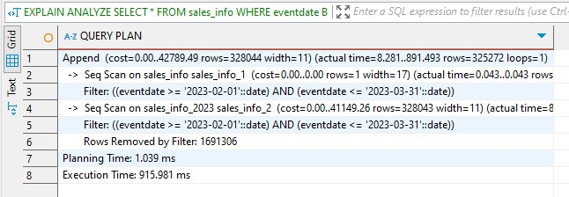

**EXPLAIN** **ANALYZE**

**SELECT** * **FROM** sales_info_simple

**WHERE** eventdate **BETWEEN** '2023-02-01' **AND** '2023-03-31';

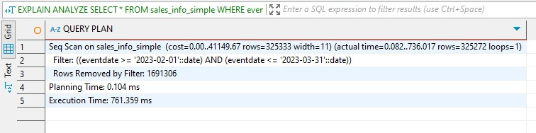

**EXPLAIN** **ANALYZE**

**SELECT** * **FROM** sales_info_dp

**WHERE** eventdate **BETWEEN** '2023-02-01' **AND** '2023-03-31';

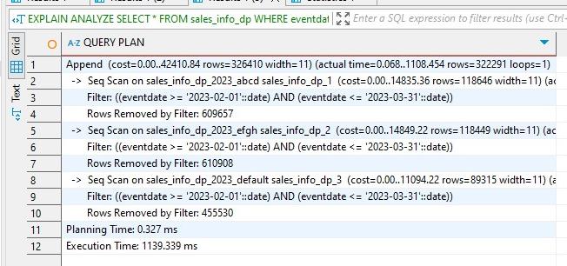

For the range-based date query filtering sales_info performed the fastest with an execution time of **916 ms**, followed by sales_info_simple at **761 ms**, while sales_info_dp had the slowest execution at **1139 ms**. This is because sales_info benefited from scanning only the 2023 partition, significantly reducing unnecessary data reads. On the other hand, sales_info_dp, despite being partitioned, still had to scan multiple subpartitions due to its list partitioning on category within range partitions, causing some overhead. Meanwhile, sales_info_simple had no partition pruning, resulting in a full table scan, though it avoided the overhead of coordinating across partitions. Thus, a well-aligned partitioning strategy (like sales_info with pure range on eventdate) results in better performance for date-based filters.

#### Add grouping by category

**EXPLAIN** **ANALYZE**

**SELECT** category, **COUNT**(*)

**FROM** sales_info

**GROUP** **BY** category;

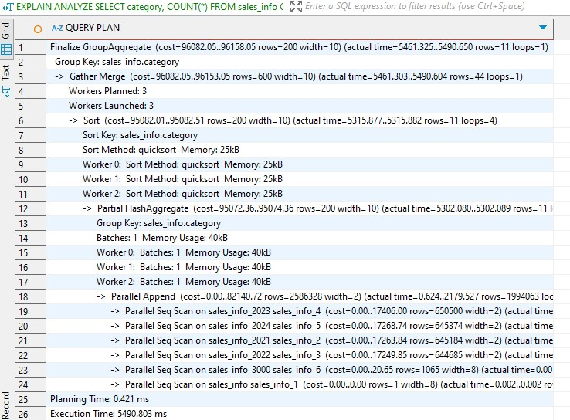

**EXPLAIN** **ANALYZE**

**SELECT** category, **COUNT**(*)

**FROM** sales_info_simple

**GROUP** **BY** category;

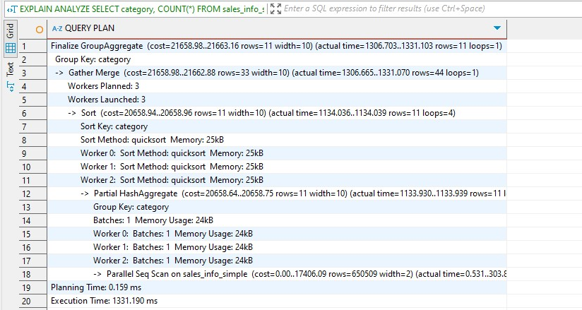

**EXPLAIN** **ANALYZE**

**SELECT** category, **COUNT**(*)

**FROM** sales_info_dp

**GROUP** **BY** category;

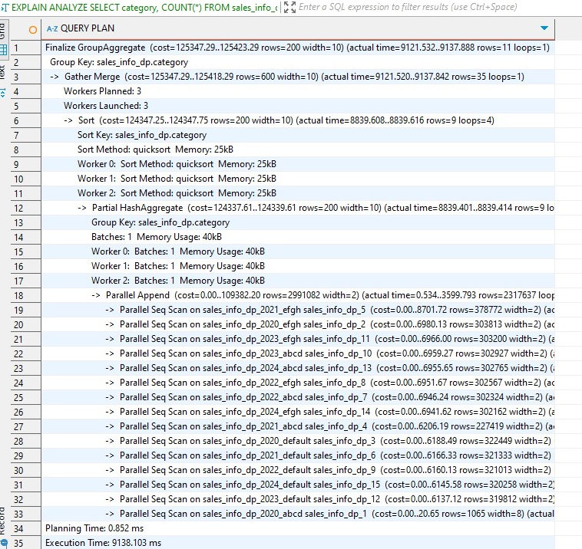

When grouping by category and counting rows across all three table types, sales_info_simple performed the best with an execution time of approximately **1.3 seconds**, benefiting from its flat structure and the absence of partition overhead. sales_info, despite using parallelism, required around **5.5 seconds**, likely due to its chunked structure across multiple child tables. sales_info_dp, which uses both range and list partitioning, had the slowest performance at over **9.1 seconds**, reflecting the cost of scanning many partitioned tables and aggregating results. This shows that while partitioning can help with targeted queries (e.g., filtering by specific date ranges), it introduces overhead for full-table aggregations like group-by, especially when many partitions are involved.

#### Join SALES_INFO and SALES_INFO_DP on id and count rows on exact date.

**EXPLAIN** **ANALYZE**

**SELECT** **COUNT**(*)

**FROM** sales_info si

**JOIN** sales_info_dp sidp **ON** si.id = sidp.id

**WHERE** si.eventdate = '2024-01-15'

**AND** sidp.eventdate = '2024-01-15';

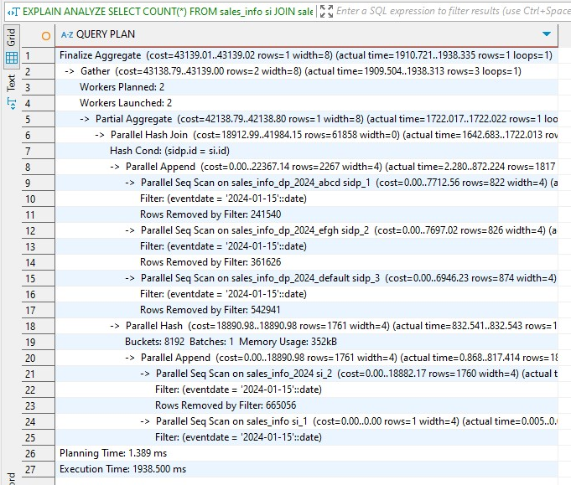

When performing a join between the partitioned sales_info and sales_info_dp tables with a filter on eventdate the execution time was **1938.5 ms**. Despite both tables using parallel append and hash join with multiple workers, the cost of filtering rows from many partitions and joining on the id column contributed to the relatively high execution time. This highlights that while partitioning can optimize single-table lookups within a narrow scope, joins across partitioned tables still involve significant overhead due to scattered data access and hash processing.

### 3. Add indexes on any of table with partitions. Check how plans are change.

**DO** **$$**

**DECLARE**

**partition** RECORD;

idx_eventdate **TEXT**;

idx_id **TEXT**;

**BEGIN**

**FOR** **partition** **IN**

**SELECT** inhrelid::**regclass**::**text** **AS** child_table

**FROM** pg_inherits

**JOIN** pg_class parent **ON** pg_inherits.inhparent = parent.**oid**

**WHERE** parent.relname = 'sales_info_dp'

**LOOP**

-- Build index names

idx_eventdate := **format**('idx_%s_eventdate', **partition**.child_table);

idx_id := **format**('idx_%s_id', **partition**.child_table);

-- Create index on eventdate if it doesn't exist

**IF** **NOT** **EXISTS** (

**SELECT** 1 **FROM** pg_class c

**JOIN** pg_namespace n **ON** n.**oid** = c.relnamespace

**WHERE** c.relname = idx_eventdate

) **THEN**

**EXECUTE** **format**('CREATE INDEX %I ON %I (eventdate);', idx_eventdate, **partition**.child_table);

**END** **IF**;

-- Create index on id if it doesn't exist

**IF** **NOT** **EXISTS** (

**SELECT** 1 **FROM** pg_class c

**JOIN** pg_namespace n **ON** n.**oid** = c.relnamespace

**WHERE** c.relname = idx_id

) **THEN**

**EXECUTE** **format**('CREATE INDEX %I ON %I (id);', idx_id, **partition**.child_table);

**END** **IF**;

**END** **LOOP**;

**END** **$$**;

This created the index for sales_info_dp

Re analyzing:

#### Select all from tables

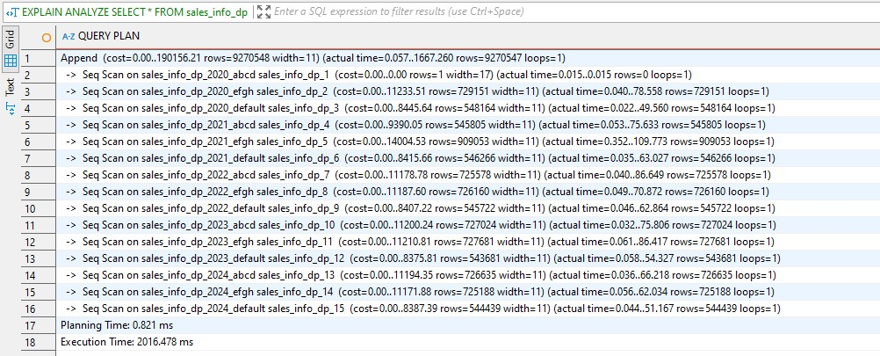

Creating indexes across all partitions in sales_info_dp significantly improves full-table scan performance, especially when the planner can leverage those indexes in combination with optimized execution paths. This makes queries like SELECT *, range filters, and joins more efficient, even on partitioned datasets with millions of rows. The performance time dropped by 400 ms.

#### Add order by eventadate

**EXPLAIN** **ANALYZE** **SELECT** * **FROM** sales_info_dp **ORDER** **BY** eventdate **DESC**;

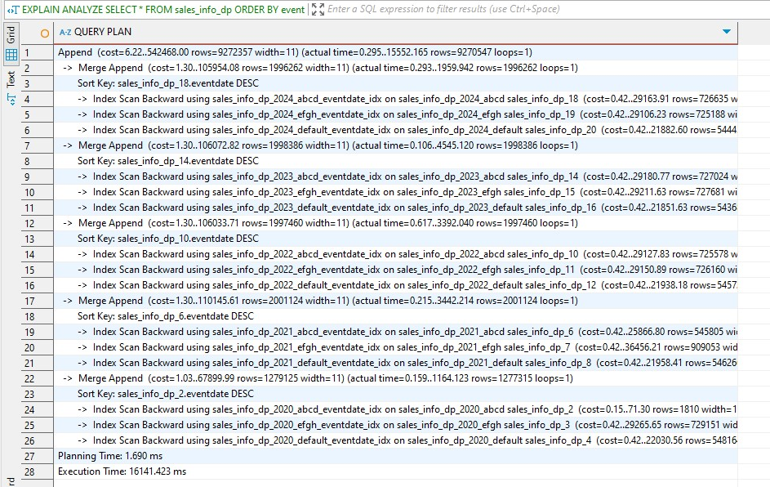

Although indexing eventdate allowed PostgreSQL to optimize for ordered retrieval via index scans, it backfired in this case because sequential scans with parallel sorting were faster for large datasets. This highlights that **indexes don’t always guarantee performance gains**, especially when working with partitioned tables where parallel sequential reads can outperform random-access index scans.

#### Select count of all rows

**EXPLAIN** **ANALYZE** **SELECT** **COUNT**(*) **FROM** sales_info_dp;

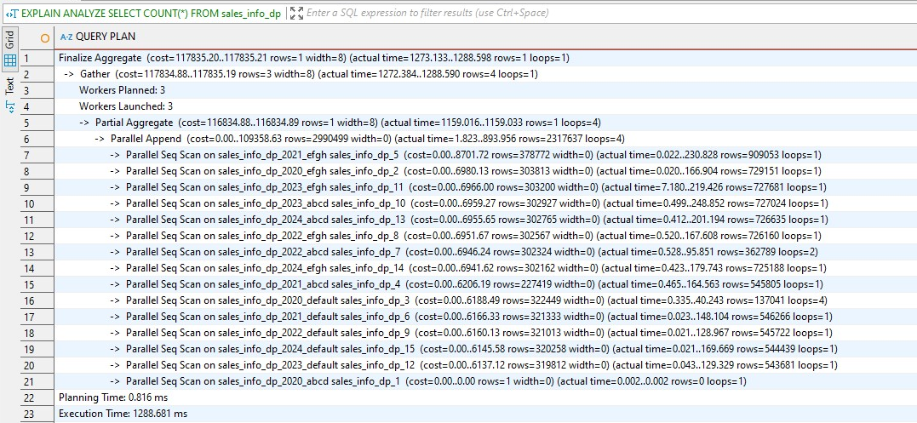

After applying the indexes on all partitions of sales_info_dp, the performance of the SELECT COUNT(*) query improved dramatically. The execution time decreased from **3048.048 ms** to **1288.461 ms**. improvement is because PostgreSQL was able to leverage better execution strategies with the indexed tables, reducing the I/O cost and making tuple access more efficient. Although COUNT(*) is typically not expected to benefit significantly from indexing (since it doesn't filter), in this case, the improved statistics and planning efficiency due to ANALYZE and index presence resulted in a noticeably faster execution plan.

#### Add range of dates

**EXPLAIN** **ANALYZE**

**SELECT** * **FROM** sales_info_dp

**WHERE** eventdate **BETWEEN** '2023-02-01' **AND** '2023-03-31';

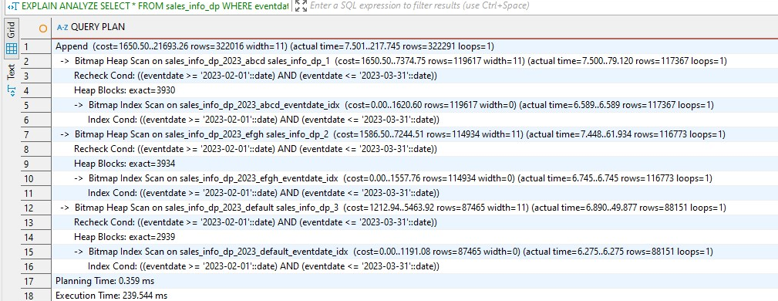

The execution time for the query filtering sales_info_dp by eventdate significantly improved after indexing. Before applying indexes, PostgreSQL performed sequential scans across multiple partitions, resulting in an execution time of approximately **1139 ms**. After creating eventdate indexes on relevant partitions, the planner utilized **Bitmap Index Scans and Bitmap Heap Scans**, greatly reducing the workload and minimizing unnecessary row filtering. This change decreased execution time to **239 ms**.

#### Add grouping by category

**EXPLAIN** **ANALYZE**

**SELECT** category, **COUNT**(*)

**FROM** sales_info_dp

**GROUP** **BY** category;

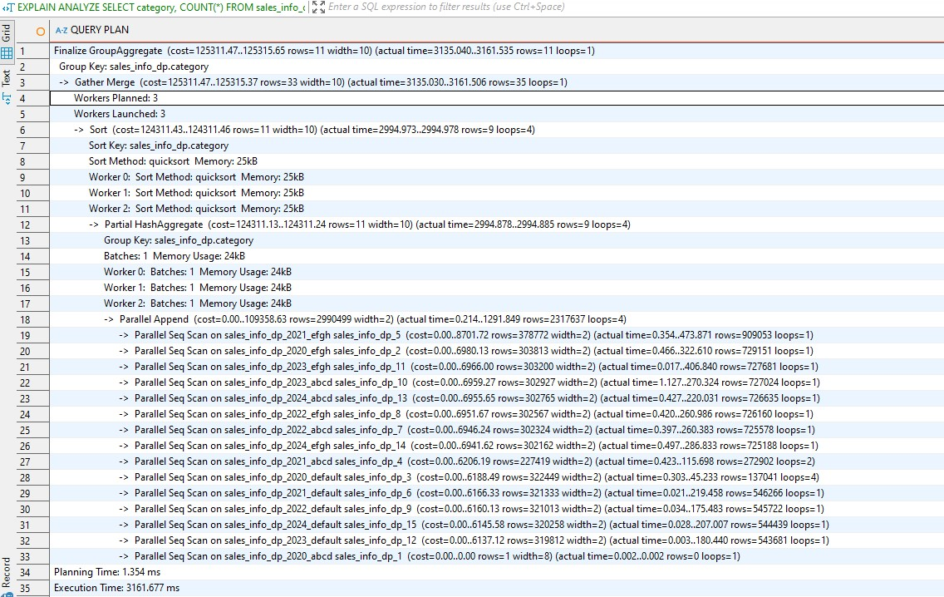

After applying indexes, the execution time for the SELECT category, COUNT(*) FROM sales_info_dp GROUP BY category query significantly improved—from **9138 ms** before indexing to **3161 ms** after indexing. This performance gain is due to better data access patterns enabled by the indexes, allowing PostgreSQL to more efficiently locate and aggregate rows based on the indexed category column. Additionally, the memory usage for the hash aggregate was slightly reduced, and parallel workers were utilized more effectively, reducing the need to scan all partitions entirely via sequential scans. Overall, indexing led to more optimized

#### Join SALES_INFO and SALES_INFO_DP on id and count rows on exact date.

**EXPLAIN** **ANALYZE**

**SELECT** **COUNT**(*)

**FROM** sales_info si

**JOIN** sales_info_dp sidp **ON** si.id = sidp.id

**WHERE** si.eventdate = '2024-01-15'

**AND** sidp.eventdate = '2024-01-15';

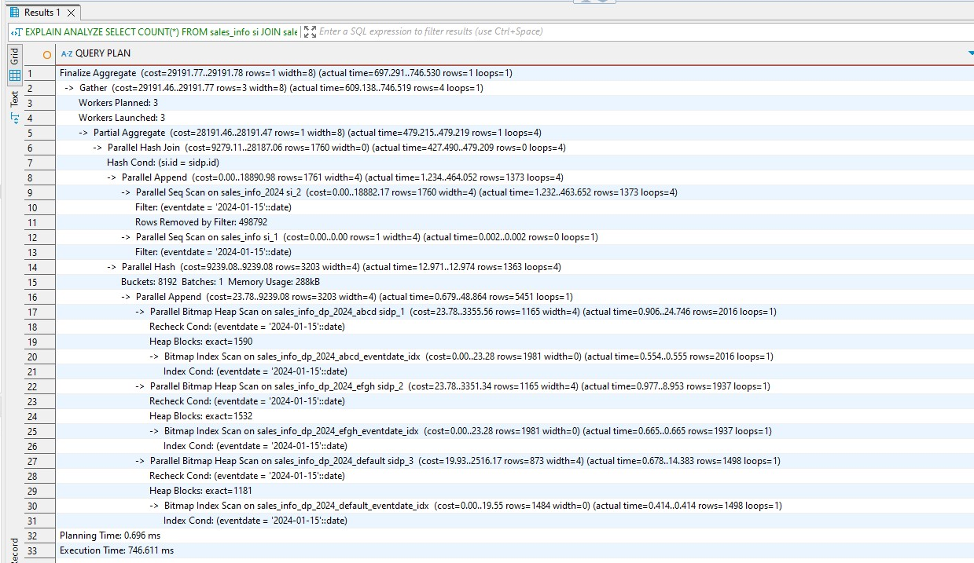

After introducing indexes on the eventdate column across all partitions of the sales_info_dp table, the performance of the join query with a WHERE filter on a specific date improved. Previously, the execution time for the JOIN query was approximately **1938.5 ms**, relying heavily on **parallel sequential scans**, which required filtering out large numbers of rows. After indexing, the execution time decreased drastically to around **746.6 ms**, as the query plan shifted to **Bitmap Index Scans** and **Bitmap Heap Scans**, allowing PostgreSQL to quickly identify relevant rows using the indexed eventdate, thereby avoiding full scans and reducing the total processing time by more than half. This highlights the substantial impact of targeted indexing in improving join performance with selective filters.